**VISVESVARAYA TECHNOLOGICAL UNIVERSITY**

**“JNANA SANGAMA”, BELAGAVI– 590018**



**MINI PROJECT REPORT ON**

**“RAINBOW FORMATION DURING RAIN USING OPENCV ”**

Submitted in partial fulfillment of Sixth Semester Computer Graphics and Image processing Laboratory (21CSL66) in Computer Science and Engineering

**Submitted By,**

**PRUTHVIRAJ C A : 4GH21CS032**

**Under the Guidance of**

**Dr.Vasantha Kumara M** B.E, M.Tech, Ph.D**.**

Assistant Professor

Dept. of CSE

GEC, Hassan

**DEPARTMENT OF COMPUTER SCIENCE & ENGINEERING,**

**GOVERNMENT ENGINEERING COLLEGE,**

**HASSAN-573201**

**GOVERNMENT ENGINEERING COLLEGE HASSAN – 573 201**

Affiliated to VTU, Belagavi & Approved by AICTE, New Delhi

**DEPARTMENT OF COMPUTER SCIENCE & ENGINEERING**



**2023-24**

**CERTIFICATE**

Certified that the Mini Project entitled “**RAINBOW FORMATION DURING RAIN USIG OPENCV**”carried out by **Mr. Pruthviraj C A(4GH21CS032)** a bonafide student of **Government Engineering College, Hassan** in partial fulfillment of **Sixth semester** in **Computer Graphics and Image processing Laboratory (21CSL66) Bachelor of Engineering** in **Computer Science and Engineering** of the **Visvesvaraya Technological University**, **Belagavi** during the year 2023-2024. It is certified that all correction / suggestions indicated during internal evaluation has been incorporated in the report. The Mini Project report has been approved as it satisfies the academic requirements in respect of Mini Projectwork prescribed for the said Degree.

**Project Guide Head of the Department**

**_____________________ ____________________**

**Dr.Vasantha Kumara M** BE, M.Tech, Ph.D .**Dr.Vani V G** B.E, M.Tech, Ph.D.

Assistant Professor Head of the Department

Dept. of CSE Dept. of CSE

GEC, Hassan GEC, Hassan

**External Viva**

**Name and Signature of Examiner with Date:**

**1.**

**2.**

**CERTIFICATE**

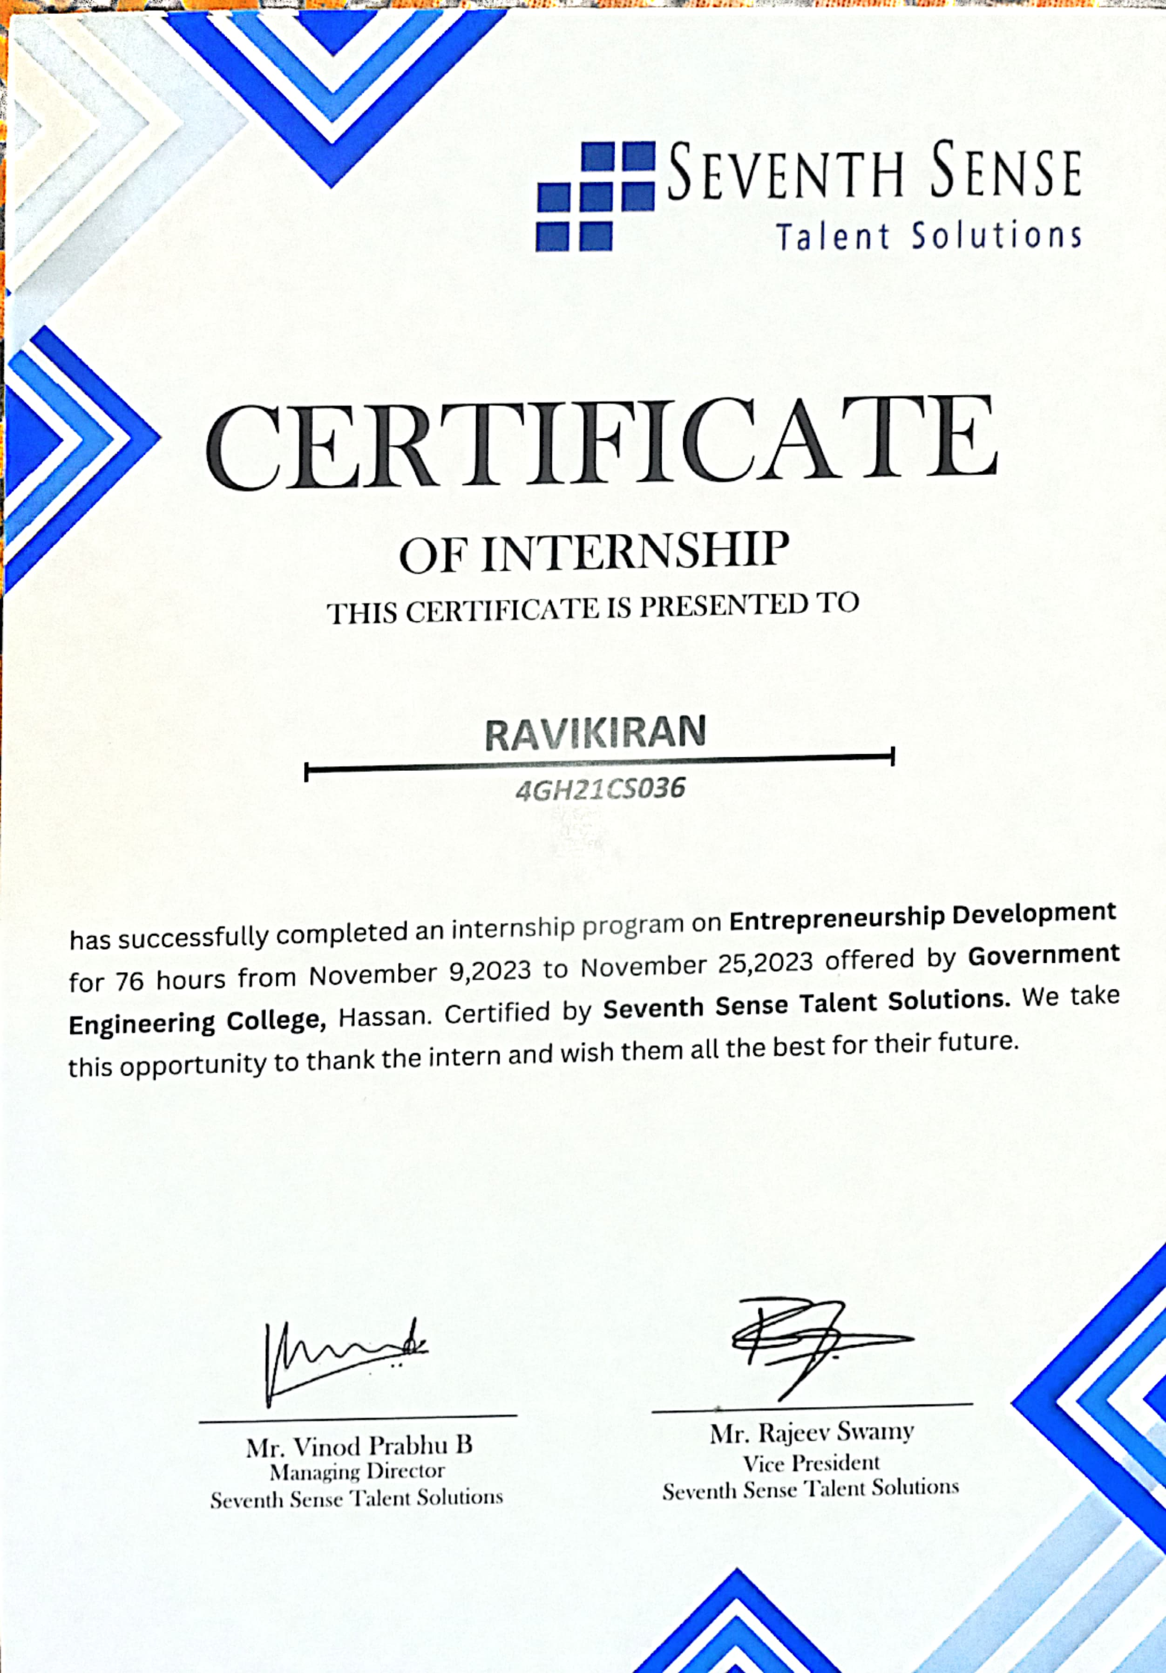

**i**

**ACKNOWLEDGEMENT**

I consider it a privilege to whole-heartedly express my gratitude and respect to each and every one who guided and helped us in the successful completion of this Internship Report.

I, very thankful to the Principal **Dr. Girish D P**,B.E, MTech, PhD**,**for being kind enough to provide me an opportunity to work on a internship in this institution.

I, also thankful to **Dr. Vani V G**B.E, MTech, HOD, Department of Computer Science, and guide of the internship , for her co-operation and encouragement at all moments of my approach.

I would greatly mention the enthusiastic influence provided by **Prof. Shylaja N S,** B.E, M. Tech**,** Assistant Professor, as Internship Coordinator for her ideas and co-operation showed on me during my venture and making this Internship as a great success.

I would also like to thank our parents and well-wishers as well as our dear classmates for their guidance and their kind co-operation.

Finally, it is my pleasure and happiness to the friendly co-operation showed by all the staff members of Computer Science Department, GECH.

**RAVIKIRAN : 4GH21CS036**

**ii**

**TABLE OF CONTENTS**

**Certificate………………………………………………….........................................i**

**Acknowledgement………………………………………….......................................ii**

**Table of Content……………………………………………...................................iii-v**

**Abstract……………………………………………………………………………...vi**

**About the Organization………………………………............................................vii**

**1. EDP PROGRAMME ORIENTATION…………………………………………1**

* 1. INTRODUCTION………………………….......................................1

**2. ENTREPRENEURIAL ROADMAP……………………………………………3**

2.1 BUSINESS IDEA GENERATION………………………………………3

2.2 VALIDATION…………………………………………………………...4

2.3 BUSINESS MODELS…………………………………………………...5

**3. ENTREPRENEUR SKILL SETS……………..………………………………..6**

**4.BUSINESSVENTURETYPESANDREGISTRATIONPROCESS…………....7**

4.1 BUSINESS VENTURE TYPES………………………………………...7

4.2 REGISTRATION PROCESS…………………………………………..7-8

**5. STATUTORY REGISTRATION ANDCOMPLIANCE…………………….9**

**6.STATUTORY BOOK KEEPING AND UNDERSTANDING OF FINANCIAL STATEMENTS…………………………………………………………………….10**

6.1 STATUTORY BOOK KEEPING………………....................................10

6.2 UNDERSTANDING OF FINANCIAL STATEMENTS...…..................11

**7. COSTING, PRICING AND TECHNIQUES OF COST REDUCTION….....12**

7.1COSTING…………………………………………………………….....12

7.2 PRICING………………………………………………………………..13

**8. IT, ERP AND INTERNAL CONTROL SYSTEMS …………………………14**

8.1 INFORMATION TECHNOLOGY (IT)………………………..………14

**iii**

8.2 ERP…………………………………………………………………….14

8.3 INTERNAL CONTROL SYSTEMS………………………………….15

**9. MARKETING METHODS AND TECHNIQUES…….................................16**

**10. DIGITAL MARKETING AND SOCIAL MEDIA PROMOTION………17**

**11. INCOME TAX AND COMPLIANCE……………………………………..18**

**12. GST AND COMPLIANCE……………………………................................19**

**13. COMPANY LAW AND COMPLIANCE…………………………….……20**

**14. EXPORTS & FOREIGN EXCHANGE…………………………………....21**

**15. SOCIAL ENTERPRISE, CORPORATE SOCIALRESPONSIBILITY**

**AND FUNDING METHODS….…22**

15.1 SOCIAL ENTERPRISE……………………………………………..22

15.2 CORPORATE SOCIAL RESPONSIBILITY….................................22

15.3 FUNDING METHODS FOR SOCIAL ENTERPRISES………….22-23

**16. STARTUP'S FUNDING AND GROWTH TECHNIQUES………………24**

**17. RURAL & WOMEN ENTREPRENEURSHIPMODELS……………….25**

17.1 RURAL ENTREPRENEURSHIP MODELS……………………….25

17.2 WOMEN ENTREPRENEURSHIP MODELS……………………...25

**18. UNDERSTANDING OF BANKING AND FINANCESYSTEM………...26**

18.1 BANKING SYSTEM………………………………………………..26

18.2 FINANCE SYSTEM……………………………………………..….26

**19. BANKS & OTHER FINANCIAL INSTITUTIONAL SCHEMES………27**

19.1 BANKING SCHEMES………………………………………………27

19.2 FINANCIAL INSTITUTIONS' SCHEMES……………………..…..27

**20. GOVERNMENT SCHEMES…......................................................................28**

**iv**

**21. RISK TYPE AND ITS MITIGATION………………………………….......29**

**22. GROWTH, EXPANSION AND SUSTAINABILITY OF BUSINESS……30**

22.1 GROWTH…………………………………………………………….30

22.2 EXPANSION…………………………………………………………31

22.3 SUSTAINABILITY…………………………………………….…….31

**Conclusion…………………………………………………………………………32**

**References……………………………………………………………………...….33**

**V**

**ABSTRACT**

The Entrepreneurship Development Internship offers a dynamic platform for aspiring entrepreneurs to gain hands-on experience in business creation and management. Participants will engage in real-world projects, enhancing their skills in market analysis, strategic planning, and innovative problem-solving. Through mentorship from seasoned entrepreneurs, workshops, and collaborative networking opportunities, interns will develop a comprehensive understanding of the entrepreneurial landscape. The program aims to foster creativity, resilience, and leadership, equipping interns with the knowledge and confidence to launch and sustain successful ventures. This immersive experience is designed to ignite entrepreneurial passion and drive sustainable economic growth.

**vi**

**ABOUT THE ORGANIZATION**

**SEVENTH SENSE TALENT SOLUTIONS**

IIM Bangalore alumni founded and manage Seventh Sense. The vision is to help students secure their dream jobs and careers and that is the guarantee we provide through our services. We are a team that believes that cost effective and high quality content coupled with intelligent test packages can help any student succeed

Seventh Sense is a Talent Solutions company founded and managed by alumni of the Indian Institute of Management Bangalore (IIM B). With a vision to help students secure their dream jobs and careers, we are dedicated to providing cost-effective, high-quality content and intelligent test packages designed to ensure student success. Our services guarantee continual improvement, helping students enhance their strengths and address their weaknesses.

Seventh Sense is an IIM Bangalore alumni-led venture into recruitment services and training solutions for premier colleges and corporates across the country. We help corporates exploit critical talent opportunities through our Recruitment Solutions and Soft Skill Training Solutions. We also focus on enhancing life skills in fresh graduates, equipping them with the necessary skills to excel in life and their careers.

### **KEY OFFERINGS**

1. **Learning Solutions**: Seventh Sense provides a comprehensive learning platform with detailed concepts, quizzes, and comprehensive tests designed to help students prepare for various exams.
2. **Corporate Training**: They offer corporate learning and training solutions managed by experienced professionals with extensive industry experience.
3. **Test Packages**: They offer a variety of test packages, including mock tests and company-specific tests, to help students prepare for placement exams.

**vii**